**Contents**

**Chapter no Title**

**1 INTRODUCTION**

**2 HARDWARE AND SOFTWARE REQUIREMENTS**

2.1 Hardware Specifications

2.2 Software Specifications

**3 TOOLS AND TECHNOLOGIES**

**4 TEST CASE**

**5**  **ANALYSIS AND DESIGN**

5.1 Analysis

5.2 Design

**6 TABLE MAPPING**

**7 DATABASE TABLE**

**8 SYSTEM ANALYSIS**

**9 SYSTEM IMPLEMENTATION**

**10 SNAPSHOTS**

**11 SOURCE CODE**

**12 CONCLUSION**

**13 FUTURE ENHANCEMENTS**

**14 BIBILOGRAPHY**

**1.INTRODUCTION**

Our project entitled “Online Shopping” is an internet web application production designed to manage the details of orders placed and the products to be delivered.

This project is mainly designed as an attempt to provide advantages of online shopping to customers of a real shop. It helps buying the product anywhere through the internet. Thus the customer will get the service of online shopping and home delivery from his favorite shop. This system can be implemented to any shop in the locality or to multinational branded shops having retail outlet chains.

If shops are providing an online portal where their customer can enjoy easy shopping from anywhere, the shops won’t be losing any more customer to the trending online shops.

**2. HARDWARE AND SOFTWARE REQUIREMENTS**

**2.1 HARDWARE SPECIFICATIONS**

PROCESSOR : 32 bit, Pentium IV or higher

RAM : 2GB

HARD DISK : 20GB(Minimum)

MONITOR : 1024x768(RESOLUTIONS)

* **SOFTWARE SPECIFICATIONS**

OPERATING SYSTEM : Windows 7 or higher

FRONT END : HTML 5,CSS,JAVA Script

BACK END : MySql

SERVER SCRIPTING LANGUAGE : PHP

WEB SERVER : Apache Web Server

WEB BROWSER : Google Chrome

**3. TOOLS AND TECHNOLOGIES**

* **Introduction to PHP**

PHP is an open source server side scripting language. We can create dynamic web pages with the PHP scripting language. A dynamic Webpage interacts with the user, so that each user visiting the page sees customized information. PHP can also be used to create dynamic web pages that are generated from information accessed from MySQL database. We can embed PHP commands within a standard HTML page. PHP’s syntax is similar to that of C and Perl, making it easy to learn for anyone with basic programming skills. The MySQL development project has made its source code available under the terms of the GNU General Public License, as well as under a variety of proprietary agreements. MySQL is written in C and C++.

MySQL, can be built and installed manually from source code, but this can be tedious so it is more commonly installed from a binary package unless special customizations are required. One most Linux distributions the package management system can download and install MySQL with minimal effort, through further configuration is often required to adjust security and optimization settings.

* **Introduction to html**

Web pages are written in language called HTML. HTML allows users to produce with pages that included texts, graphics and pointers to other web pages. HTML is a mark up language, a language describing how language are to be formatted.

HTML is a free defined set of tags to format texts, create hyperlinks to other places, and insert graphic images. When a web browser open an HTML file, it displays the page based on the tags, it’s a simple, universal mark-up language that allows web publishers to create complex pages of texts and images that can be viewed by anyone else on the web.

HTML allows us to publish documents to the internet in a platform independent format. It creates links to a related work from the document. HTML is used here to capture User/Advisor input and covey it to an application on the server.

An HTML form is simply a session of document that begins with<FORM> tag followed by any number of input elements and a closing </FORM> tag.

The input elements within a form can be specified in ways

* The <INPUT>tag
* The <TEXTAREA>tag
* The<SELECT>and<OPTION>tags

**HTTP**

HTTP is a language used to describe how web documents are sent over the internet. A web server operates by listening for requests on a well-known port number. The default is port 80, although any available port can be used. If a web server listens on a different port, URL’s that refer to this server must include a colon and the port number immediately after the server name

**4.TEST CASES**

**TEST CASE 1: USER LOGIN INTO THE SYSTEM**

|  |  |
| --- | --- |
| INPUT | 1.Enetr the valid phonenum and password  2.Enter the invalid phonenum and passwords |
| RESULT | 1. Login successful.  2. Error message ‘Invalid phonenum and password’. |
| CONDITION | User should have unique phonenum and password to login to the system. |

**TEST CASE 2: ORDER TABLE**

|  |  |
| --- | --- |
| INPUT | 1. Choose products.  2.Enter the products name, products quantity, name, e-mail, address |
| RESULT | 1.Order placed |

**5. ANALYSIS AND DESIGN**

**5.1 ER-Diagram**

**5.2 SCHEMA DIAGRAM**

Category

|  |
| --- |
| category |

Products

|  |  |  |  |  |
| --- | --- | --- | --- | --- |
| Category | Name | image | price | description |

User

|  |  |  |
| --- | --- | --- |
| username | email | password |

Order

|  |  |  |  |  |  |  |
| --- | --- | --- | --- | --- | --- | --- |
| productimage | productname | Price | quantity | username | email | address |

Cancelorder

|  |  |  |  |
| --- | --- | --- | --- |
| productimage | productname | username | time |

**6. Table mapping**

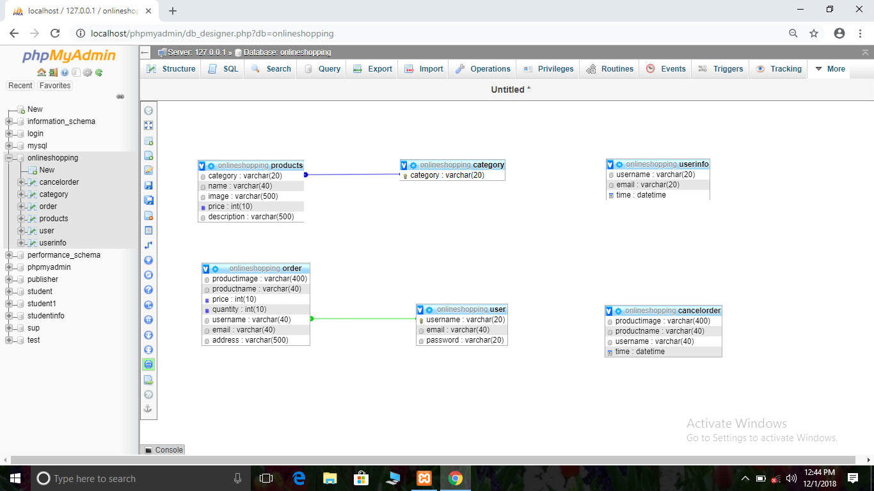

**7. Database Tables**

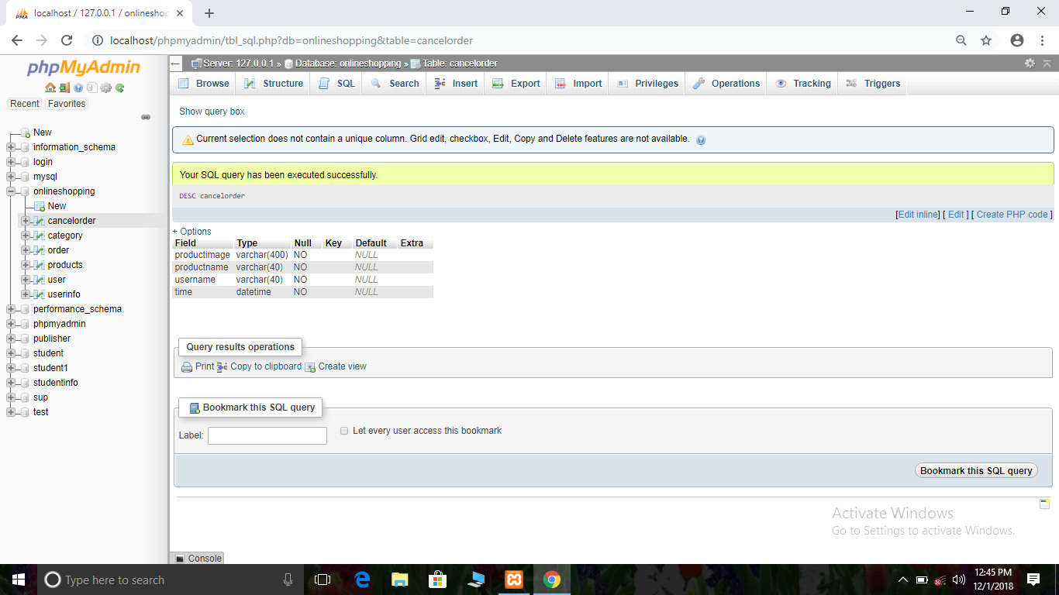

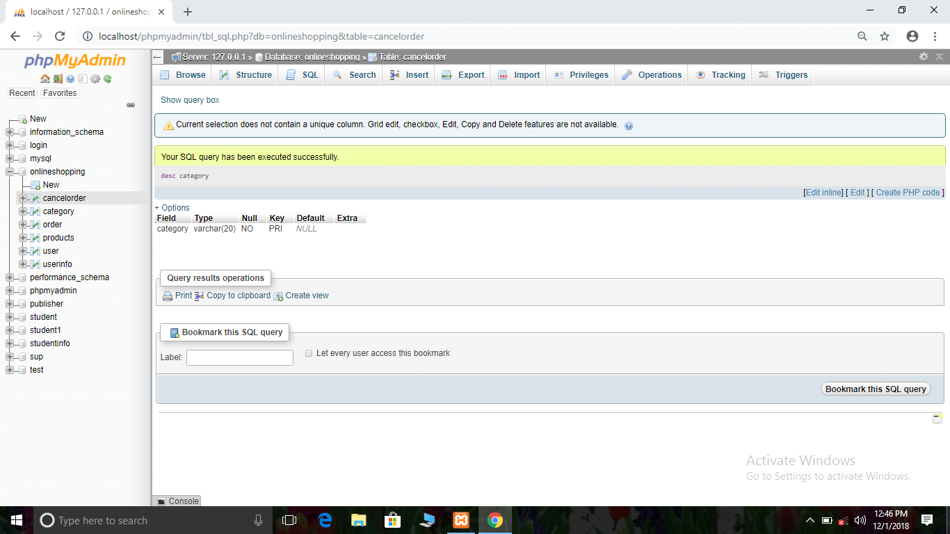

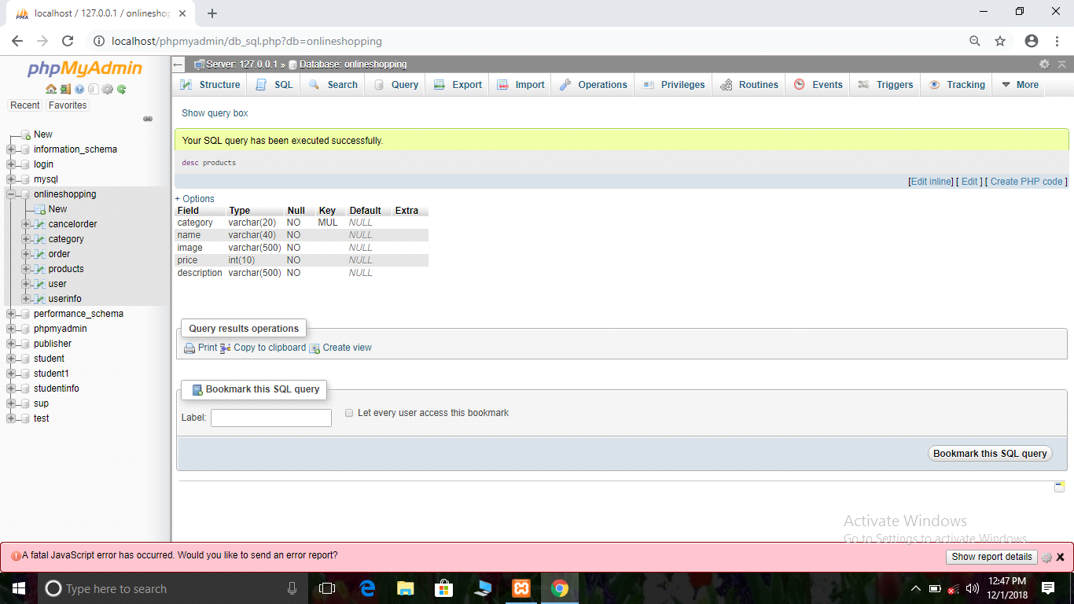

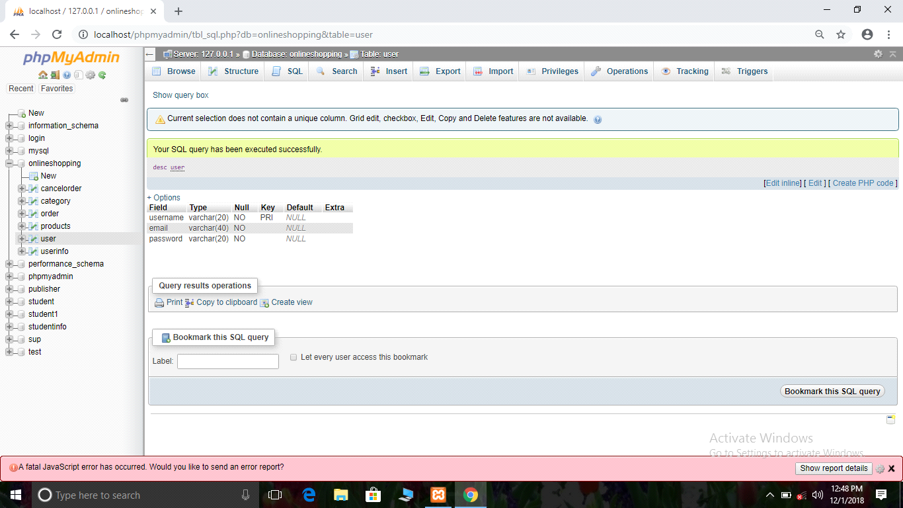

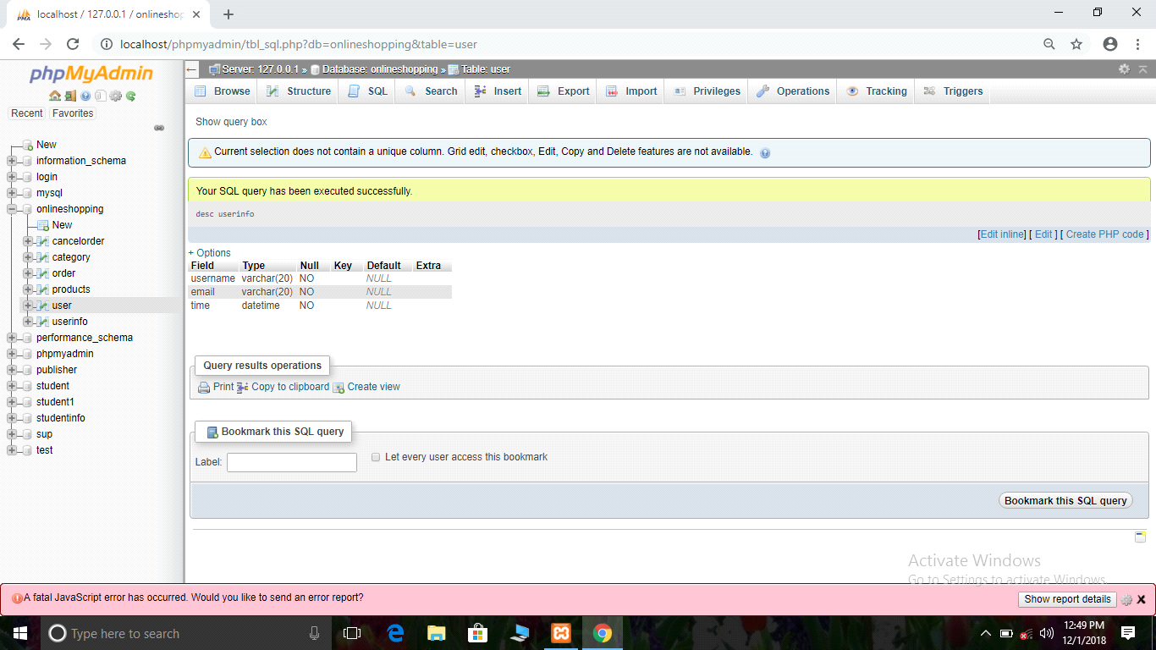

**8. SYSTEM ANALYSIS**

EXISTING SYSTEM

The current systems for shopping is to visit the shop manually and from the available product choose the item customer want and buying the item by payment of the price of the item.

* It is the user-friendly.
* User must go to shop and select products.
* It is the difficult to identify the required product.
* Description of the product limited.
* It is a time consuming process
* Not in reach of distant users.

PROPOSED SYSTEM

In the proposed system customer need not go to the shop for buying the products .He can order the product he wish to buy through the application in his Smartphone. The shop owner will be admin of the system. Shop owner can appoint moderators who will help owner in managing the customers and product orders. The system also recommends a home delivery system for the purchased products.

**9. SYSTEM IMPLEMENTATION**

Implementation is the stage of the project where the theoretical design is turned into a working System. It can be considered to be the most crucial stage in achieving a successful new system gaining the users confidence that the new system will work and will be effective and accurate. It is primarily concerned with user training and documentation. Conversion usually takes place about the same time the user is being trained or later. Implementation simply means conveying new system design into operation, which is the process of converting a new revised system design into an operational one.

Implementation includes all those activities that takes place to convert from the existing system to the new system .the new system may be a totally new, replacing an existing manual or automated system or it may be a modification to existing system. Proper implementation is essential to provide a reliable system to meet organization requirements. The process of putting the develop system in actual use is called system implementation. This includes all those activities that takes place to convert from the hold system to the new system. the system can be implemented only after through testing is done if it is found to be working according to the specifications .the system personnel check the feasibility of the system being implemented, the more involved will be the system analysis and design effort required to implement the three main aspects: education and training, system testing changeover.

Implementation also involves Packaging, handling, and storage, depending on the concerned technologies and where or when the system requirement needs to be integrated into a higher-level aggregate. Developing the supporting documentation for a system requirement, such as the manuals for operation, maintenance, and/or installation, is also a part of the implementation process; these artifacts are utilized in the system deployment and use phase. The implementation state involves the following tasks:

* Careful planning.
* Investigation of system and constraints.
* Design of methods to achieve the changeover.

**10. SNAPSHORTS**

**LOGIN**

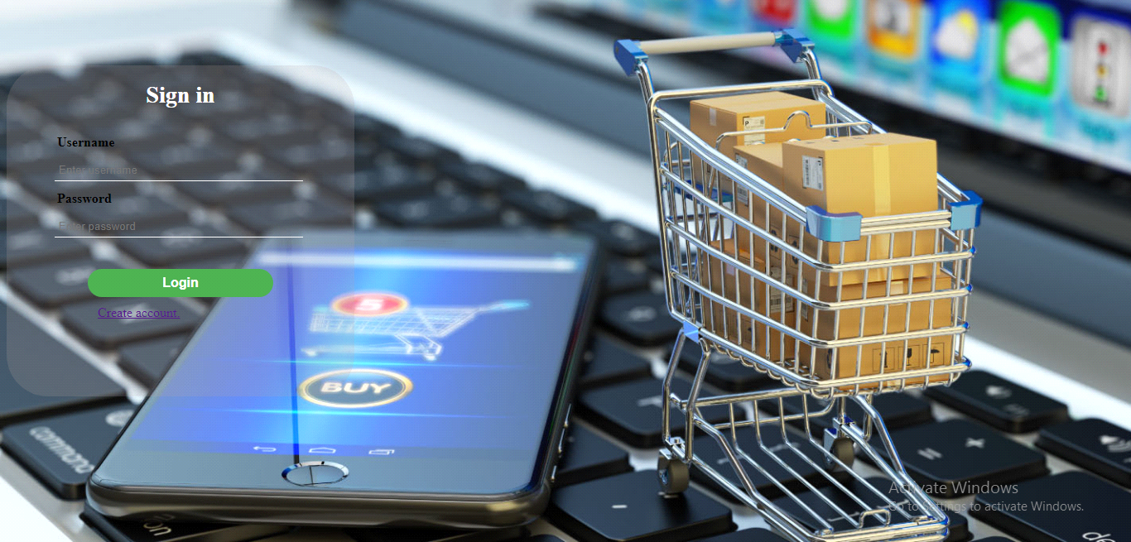

**HOME**

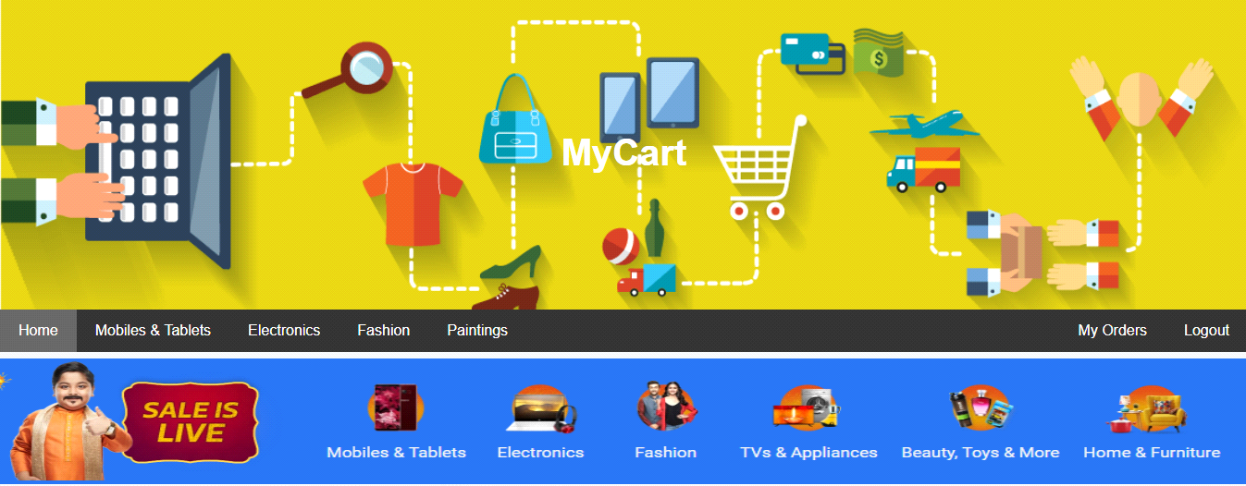

**PRODUCTS**



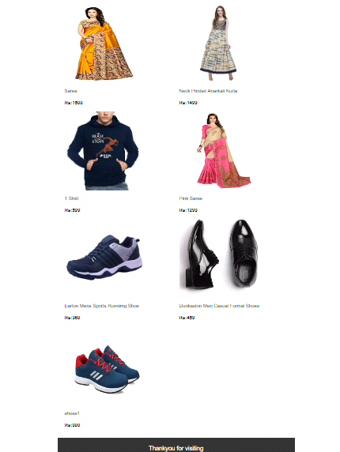

**ORDERS**

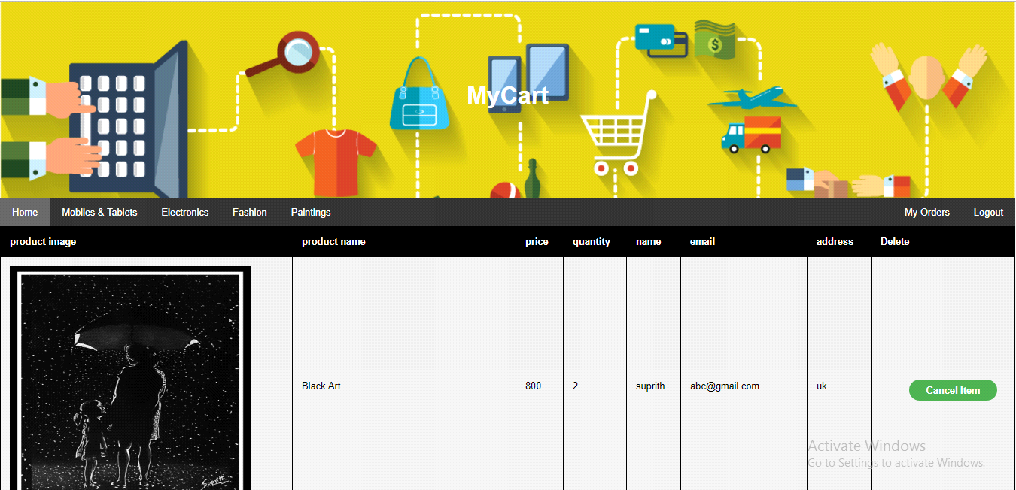

**USERS**

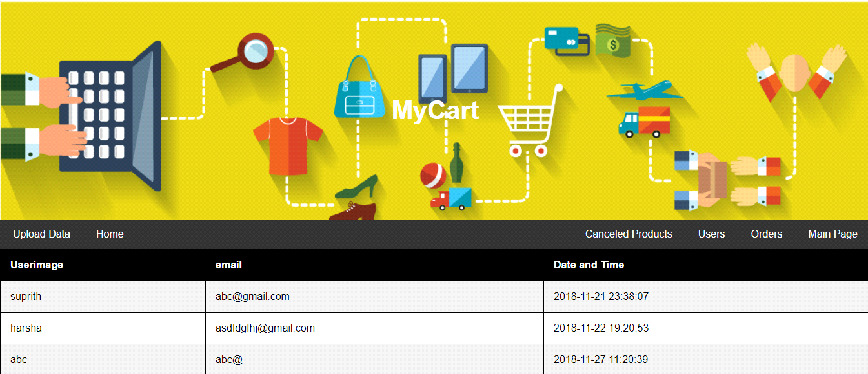

**ADMIN**



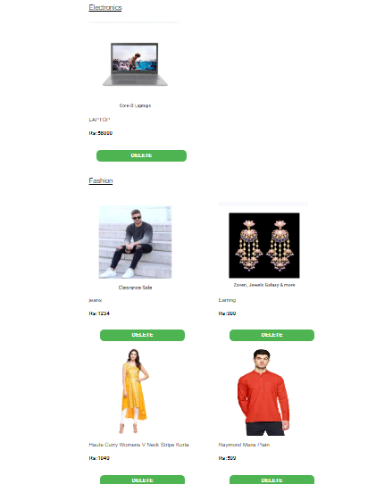

**UPLOAD**

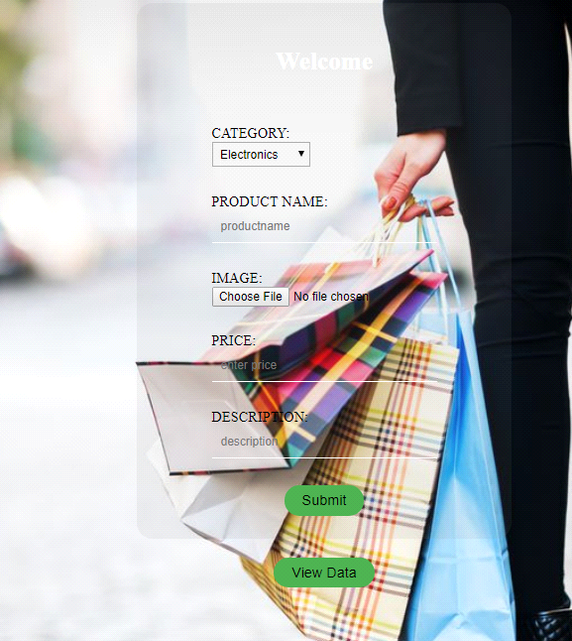

**11. SOURCE CODE**

**loginmain.php:**

<html>

<head>

<link rel="stylesheet" type="text/css" href="login.css">

</head>

<body>

<div class="form">

<form action="login.php" method="post">

<h3>Sign in</h3>

<div class="field">Username</div>

<div id="mail">

<input type="text" placeholder="Enter username" name="username" required="*" maxlength="30">

</div>

<div class="field">Password</div>

<div id="password">

<input type="password" placeholder="Enter password" name="password" required="" maxlength="15" minlength="3">

</div>

<div id="button">

<input type="submit" name="submit" value="Login" >

</div>

<div class="last">

<a href="register.php">Create account.</div>

</form>

</div>

</body>

</html>

**Buy:**

<?php

session_start();

include 'connect.php';

$name=$_POST["name"];

$sql=$mysqli->query( "SELECT `category`, `name`, `image`, `price`, `description` FROM `products` WHERE name='$name'");

while($result2=$sql->fetch_assoc())

{ $image= $result2['image'];

$name= $result2['name'];

$price= $result2['price'];

}

?>

<html>

<head>

<title>Page Title</title>

<link rel="stylesheet" type="text/css" href="home.css">

<link rel="stylesheet" type="text/css" href="register.css">

</head>

<style>

body{ background-image: url();

background-repeat: no-repeat;

background-size: cover;

background-attachment: fixed;

}

.container{ margin: auto;

border:none;

margin:center;

background:rgba(128,128,128,0.1);

border-radius: 18px;

width: 520px;

padding: 50px;

height: 1500px;

}</style><body>

<div class="header">

<h1>MyCart</h1>

</div>

<div class="navbar">

<a href="home.php" class="active">Home</a>

<a href="mobiles.php">Mobiles & Tablets</a>

<a href="electronics.php">Electronics</a>

<a href="fashion.php">Fashion</a>

<a href="paintings.php">Paintings</a>

<a href="logout.php" class="right">Logout</a>

<a href="order.php" class="right">My Orders</a>

</div><div class="container">

<img src="<?php echo $image;?>" height="400" width="400"/>

<form action="buyok.php" method="post">

<h2>

<table align="center">

<caption>ENTER DETAILS</caption>

<div class="contain"> <tr>

<td><input type="hidden" name="productimage" value="<?php echo $image;?>"></td>

</tr>

<tr><td><h4>PRODUCT NAME:</h4><br>

<input type="text" name="productname" value="<?php echo $name?>"></td>

</tr>

<tr>

<td><h4>Price<h4><br>

<input type="text" name="price" value="<?php echo $price;?>"></td>

</tr>

<tr>

<td><h4>Quantity<h4><br>

<input type="text" name="quantity" required="" ></td>

</tr><tr>

<td><h4>Name<h4><br>

<input type="text" name="name" value="<?php echo $_SESSION["username"]?>"></td>

</tr>

<tr>

<td><h4>Email<h4><br>

<input type="text" name="email" value=""></td>

</tr>

<tr>

<td><h4>Address<h4><br>

<input type="text" name="address" required=""></td>

</tr>

<tr>

<td align="center">

<input type="submit" value="Buy Now" ></td>

</tr> </div> </table> </h2> </form></div></div></body></html>

**View Order:**

<html>

<table border="5">

<tr>

<th>

category</th>

<th>

name</th>

<th>

photo</th>

<th>

price</th>

<th>

description</th>

</tr>

<?php

include 'connect.php';

$sql=$mysqli->query("select * from products");

while($result2=$sql->fetch_assoc()){ ?>

<tr>

<td><?php echo $result2['category'];?></td>

<td><?php echo $result2['name'];?></td>

<td><img src="<?php echo $result2['image'];?>" height="100" width="100"/></td>

<td><?php echo $result2['price'];?></td>

<td><?php echo $result2['description'];?></td></tr>

<?php

}?></table></html>

**Connect:**

<?php

$db='onlineshopping';

$server="localhost";

$username="root";

$password="";

$mysqli= new mysqli($server,$username,$password,$db) ;

?>

**12. CONCLUSION :**

The project entitled Online shopping system was completed successfully.

The system has been developed with much care and free of errors and at the same time it is efficient and less time consuming. The purpose of this project was to develop a web application and an android application for purchasing items for a shop.

This project helps us in gaining valuable information and practical knowledge on several topics like designing web pages using html & CSS, usage of responsive templates, designing of android application, and management of database using mysql. The entire system is secured. Also the project helped us understanding about the developing phases of a project and software development life cycle.

This project has given us great satisfaction in having designed an application which can be implemented to any nearby shops or branded shops selling various kinds of products by simple modifications.

There is a scope for further development in our project to a great extent. A number of features can be added to this system in future like providing moderator more control over products so that each moderator can maintain their own products. System may keep track of history of purchases of each customer and provide suggestions based on their history.

**13. Future Enhancement**

* The project can be extended to allow multiple images when user creates ad.
* The project can also be extended to add chat functionality to the application.
* It can also be extended to make it as online shopping website.
* The project can be extended to many other categories available today.
* Can improve the security level. Making the application more secure and reliable

**14. BIBILOGRAPHY :**

* [**www.w3school.com**](http://www.w3school.com/)
* [**www.sitepoint.com/article/**](http://www.sitepoint.com/article/)
* [**www.stackover.com/**](http://www.stackover.com/)
* [**www.quora.com/**](http://www.quora.com/)

**Thank You**